**EXOSKELETON: THE PHYSIOTHERAPY ROBOT**

PROJECT REPORT

Submitted by

**ARCHANA M (IES19EC006)**

**BRIJESH K BABU (IES19EC014)**

**GOPIKRISHNAN M.S (IES19EC019)**

**RASHA JALALUDEEN (IES19EC026)**

to

the APJ Abdul Kalam Technological University

in partial fulfillment of the requirements for the award of the

Degree of

Bachelor of Technology

*in*

*Electronics and Communication Engineering*

**

**Department of Electronics and Communication Engineering**

IES College of Engineering

Chittilapilly

JUNE 2023

**DEPARTMENT OF ELECTRONICS AND COMMUNICATION ENGINEERING IES COLLEGE OF ENGINEERING, CHITTILAPPILLY**



**CERTIFICATE**

This is to certify that the report entitled “**EXOSKELETON: THE PHYSIOTHERAPY ROBOT**” submitted by **ARCHANA M (IES19EC006), BRIJESH K BABU (IES19EC014), GOPIKRISHNAN M.S (IES19EC019), RASHA JALALUDEEN (IES19EC026)** to the APJ Abdul Kalam TechnologicalUniversity in partial fulfilment of the requirements for the award of the Degree of Bachelor of Technology in Electronics and Communication Engineering Branch bonafide record of the project work carried out by them under my guidance and supervision. This report in any form has not been submitted to any other University of Institute for any purpose.

|  |  |  |
| --- | --- | --- |
| **Ms. Rachana M K** | **Ms. Shahaziya Parvez M** | **Ms. Rachana M K** |
| Associate Professor | Assistant Professor | Associate Professor |
| Project Guide | Project coordinator | Head of the Department |

**ACKNOWLEDGEMENT**

We take this opportunity to express our heartfelt gratitude to all the respected personalities who have guided, inspired and helped us in the successful completion of this project phase II.

First and foremost, we owe our heartfelt gratitude to Lord Almighty for all the grace and blessings that has been showered on us throughout our academics, especially during this project phase II term.

We take this opportunity to express our thanks to our Principal **Dr. BRILLY.S. SANGEETHA** and all technical and administrative staff of IES College of Engineeringfor the various facilities provided with respect to our project phase II.

We would also extend our sincere gratitude to **Ms. RACHANA M K**, HOD, Department of ECE, IES College of Engineering for his support and suggestions.

We are thankful to our Guide **Ms. RACHANA M K**, Associate Professor, Department of ECE, IES College of Engineering for her guidance and constant support throughout the project work. Her valuable suggestions and directions have been an asset towards the completion of this project phase II.

We owe our sincere thanks to our project phase II Coordinators **Ms. SHAHAZIYA PARVEZ M** and **Ms. RACHANA M K**, Assistant professor, Department of ECE, IESCollege of Engineering for the valuable guidance and suggestions.

We also thank our tutors **Ms. SHAHAZIYA PARVEZ M** and **Ms. ANJALI RAJAN**, Assistant Professor, Department of ECE, IES College of Engineering for theircare and affection was really incredible that added strength to our progressing strides.

We extend our gratitude to all other faculty members for their constant support throughout the development of our project phase II.

Last but not the least we fondly remember all of our dear colleagues and our parents, for the moral support and love that they have shared in every pace of our work.

**ABSTRACT**

Exoskeleton robots have been designed to increase the strength and endurance of human limbs, and can enhance the physical abilities of both disabled individuals (due to accidents or stroke) and ordinary people for executing motion or manipulation tasks. It is crucial to design them in a way that ensures they are safe, comfortable, and accurate. Their functions include assisting in walking, running, jumping, or lifting heavy objects. This paper presents an upper body exoskeleton robot designed for rehabilitation applications that can be used for physiotherapy of the entire arm of a patient. The patient wears an armband device, and a physiotherapist or assistant performs predefined actions using a mobile application to control the robot. The main parts of the robot are 3D printed, and a prototype has been developed with control instruments and a designed mobile application for control over the IoT.The significant aspect of this design is that it works with the help of an Android application, which includes all control mechanisms. The robot can be operated remotely, irrespective of the distance between the application user and the patient. This means that patients do not have to travel or seek help during post-treatment, which can help doctors with their busy schedules. Additionally, the exoskeleton robot is lightweight and relatively inexpensive. This way, many middle-class and low-class families can access this medical technology in an affordable way and do not need to have a personal physiotherapist. Therefore, this technology can help improve medical technology and contribute to the economic development of our country.

**CONTENTS**

1. ACKNOWLEDGEMENT……………………………………………. iii
2. ABSTRACT…………………………………………………………... iv
3. CONTENTS………………………………………………………..…. v
4. LIST OF FIGURES…………………………………………………... vi
5. INTRODUCTION……………………………………………………. 1
6. HISTORY……………………………………………………………... 3
7. LITERATURE REVIEW……………………………………………... 4
8. EXISTING SYSTEM…………………………………………………. 9

4.1 MOTOR SKILL EXCERISE………………………………………… 9

4.2 MOBILITY TRAINING…………………………………………….. 10

4.3 CONSTRAIN NDUCED THERAPY…………………………………. 10

4.4 RANGE OF MOTION THERAPY…………………………………… 11

1. PROPOSED SYSTEM………………………………………………... 12

5.1 BLOCK DIAGRAM……….………………………………………… 13

5.2 WORKING…………….…………………………………………….. 13

5.3 CIRCUIT DIAGRAM…………………………………………………. 14

1. HARDWARE…………………………………………………………. 16

6.1 NODE MCU………………………………………………………... 16

6.2 SERVO MOTOR……………………………………………...……. 17

6.3 PULSE SENSOR……...……………………………………………. 18

6.4 TEMPERATURE SENSOR…………………………………………. 19

1. SOFTWARE………………………………………………………….. 20

7.1 ARDUINO IDE v1…………………………………………………. 20

7.2 PYCHARM………………………………………………………… 21

7.3 ANDROID STUDIO………………………………………………… 21

1. FLOW CHART AND ALGORITHM…..…………………………….. 23
2. ADVANTAGES & DISADVANTAGES…………………………….. 25
3. FUTURE SCOPE……………………………………………………... 26
4. CONCLUSION……………………………………………………….. 27

REFERENCES

**LIST OF FIGURES**

|  |  |  |
| --- | --- | --- |
| 4.1 | EXISTING SYSTEM…………………………………................... | 9 |
| 5.1 | BLOCK DIAGRAM …..……………………………..................... | 13 |
| 5.3 | CIRCUIT DIAGRAM …………………………………................ | 14 |
| 6.1 | NODE MCU…….……………………………………………….. | 16 |
| 6.2 | SERVO MOTOR ………………………………………………… | 17 |
| 6.3 | PULSE SENSOR ………………………………………………… | 18 |
| 6.4 | TEMPERATURE SENSOR ………….………………………….. | 19 |
| 10.1 | FLOW CHART…………………………………………………… | 23 |

**CHAPTER 1**

**INTRODUCTION**

India is a country with a growing population and emerging technologies, but it also faces scarcity of resources. These factors affect every aspect of our country, including clothing, food, groceries, cosmetics, hospitals, and medicine. Currently, we have 426 people who have been subjected to accidents, which may have both mental and physical effects on them.

Many hospitals lack the required equipment and medicines, but there are increasing possibilities for physical rehabilitation. Physical rehabilitation is essential for individuals with physical or neurological problems. This therapy primarily focuses on two aspects: (i) increasing the effective range of motion (Rom) of impaired joints, and (ii) repeating activities of daily living (ADLs). Robotic devices can replicate the manual labour of therapists, thereby improving patients' motor recovery and functional independence. Designing appropriate robotic devices for hand limitations is even more challenging due to the complicated anatomy and extensive movement of the hand. To overcome these challenges, designers can simplify hand devices by limiting mechanical features to specific tasks and levels of disability. Modern stationary devices for physical therapy have been effective, although most of them are built like exoskeletons. However, not all patients can regain their locomotor function at the current medical level. Therapeutic exoskeletons are also used for social rehabilitation. In this case, an exoskeleton is worn for an extended period to facilitate movement in non-functioning limbs. Existing prototypes aim to assist in the post-operative recovery of individuals who have lost their mobility. Additionally, the design envisions potential industrial applications to enhance the physical capabilities of healthy individuals.

Powerful mechanism, such as lift and move heavy object Exoskeleton robot is a mechanical system has close contact human beings. Virtual environments (VEs) to new sensory modalities. Tactile feedback reproduces surface texture, while force feedback reproduces strain. They propose to be used for the rehabilitation of patients with problems of the locomotion system. In exoskeleton, reasonable application of elastic elements can effectively reduce motor power and work, so as to select smaller motors and batteries. In addition, elastic elements can increase the flexibility and safety of Exoskeleton. Hand exoskeletons and similar devices have received continued interest as they can support more complex arrangements of forces In this system, individuals can use an exoskeleton with the help of a pre-installed Android application that contains all the control mechanisms. This allows anyone to operate the exoskeleton from anywhere. Locomotion system. In exoskeleton, reasonable application of elastic elements can effectively reduce motor power and work, so as to select smaller motors and batteries. In addition, elastic elements can increase the flexibility and safety of Exoskeleton. Hand exoskeletons and similar devices have received continued interest as they can support more complex arrangements of forces This exoskeleton provides an at-home option for therapeutic hand exercises to improve patients' dexterity and restore function. It can be an interesting option for the supply of aids if the structural and functional properties of the neuromuscular and skeletal system are too limited to be able to achieve mobilization. It has servo motors that bend

and straighten the fingers, providing the stretching and repetitive exercise needed to restore lost hand function. Low pressure and comfortable materials make this device safe and desirable for repeated use. The minimalist form factor of soft robotics allows users to go about their daily activities without discomfort or frustration while wearing the glove in its unpowered state and then smoothly transition into the gadget-like gloves powered assistance when they begin their therapeutic routine. The control system is portable and lightweight and can be placed anywhere. Using IoT and a mobile phone application, people anywhere can use them and control the patient's physiotherapy without the help of attendants. These robotic gloves, operate on the principle of tendons. By temporarily moving the muscles in the hand, this design mimics the installation of tendons in the human hand. The repetition of exercises is crucial to the recovery process. The system also helps users to use the exoskeleton without any help as it operates with the help of an Android application installed that has every control mechanism, making it easy to use. The application can be controlled anywhere by anyone, whether it's a physiotherapist, physician, doctor, relative, acquaintance, etc., irrespective of the distance between the patient and the person controlling it. The entire system is packed in an affordable way, where even temperature sensors, heart rate sensors, and blood pressure sensors can be added if needed. The control framework essentially reshapes the anisotropic force manipulability into the endpoint force manipulability that is invariant with respect to the direction in the entire workspace of the arm.This allows users of the exoskeleton to perform tasks effectively in the whole range of the workspace, even in areas that are normally unsuitable due to the low force manipulability of the human arm.The minimalist form factor of soft robotics allows users to go about their daily activities without discomfort or frustration while wearing the glove in its unpowered state, and then smoothly transition into gloves powered assistance when they begin their therapeutic routine. The control system is portable and lightweight and can be placed anywhere. The repetition of exercises is crucial to the recovery process

**CHAPTER 2**

**HISTORY**

The development of robotic exoskeletons already began in the second half of the 20th century. Around 1965, General Electric (in the US) started to develop the Hardiman, a large full-body exoskeleton designed to augment the user’s strength to enable the lifting of heavy objects. The first exoskeletons for gait assistance were developed at the end of the 1960s at the Mihajlo Pupin Institute Serbia, and in the early 1970s at the University of Wisconsin-Madison in the US.

Because of the technical limitations of their time, and the lack of experience and knowledge, it still took several decades until the technology matured and the first exoskeletons were ready for the market. With the beginning of the 21st century, the first exoskeleton products made their way to the market and are accessible to an increasing number of users. One of the first applications was gait rehabilitation in stroke and spinal cord injured patients. An early example is the gait rehabilitation exoskeleton Lokomat that was released in 2001 and is used in hospitals and rehabilitation centers worldwide. In 2013, the company behind the Lokomat (Hocoma AG) announced the shipment of the 500th device**.** Development continued in the first decade of the 21st century at an increasing number of research labs and companies.

Towards the end of the decade, several prototypes of military exoskeletons that aim to augment their user’s strength and endurance were presented. Examples are the Raytheon XOS exoskeleton, which is a full body exoskeleton, and Lockheed Martin’s “Human Universal Load Carrier” (HULC) that supports its users to carry a heavy backpack. Since 2010, several gait assistance and restoration exoskeletons have been presented and gradually introduced to the market. Most of them are designed to enable paraplegic users to leave the wheelchair and walk upright with the support of the device. Examples are the Rewalk device (ReWalk Robotics), and the Indego exoskeleton (Parker Hannifin).

In an effort to further reduce constraints that can be caused by the size, weight and rigid structure of exoskeletons, the concept of exosuits has emerged in the past couple of years. These soft, robotic devices are primarily made of textiles and can be worn like clothes. They provide support by actuated cables that are integrated into the textiles, or by soft and lightweight actuators situated at the joints. Pioneering work was conducted by the Wyss Institute at Harvard University that developed exosuits to support walking.

**CHAPTER 3**

**LITERATURE REVIEW**

1. A force augmenting exoskeleton for the human hand designed for pinching and grasping almost 1 million people suffer from debilitative disorders or injuries to the hand, which result in decreased grip strength and/or impaired ability to hold objects. The objective of this study was to design and test the functioning of a five- digit exoskeleton for the human hand that augments pinching and grasping efforts. The exoskeleton digits and the wrist and forearm structure was computer designed and 3-D printed using ABS plastic, while the housing for the control system, motors, and batteries was constructed from laser-cut acrylic. The user’s finger movement efforts were monitored with force sensing resistors (FSR) located within the fingertips of the exoskeleton. A microcomputer-based control system monitored the FSRs and commanded linear actuators that augmented the wearer’s force production. The exoskeleton device was tested on six healthy individuals. Using the device for grasping efforts significantly decreased the muscle activity necessary to maintain a constant force (p < 0.001); however, no significant benefit was identified during pinching efforts. In conclusion, a novel 5-digit exoskeleton was designed, and functional testing identified a significant benefit of using the device during grasping efforts.
2. A Hybrid, Wearable Exoskeleton Glove Equipped With Variable Stiffness Joints, Abduction Capabilities, and a Telescopic Thumb Robotic hand exoskeletons have become a popular and efficient technological solution for assisting people that suffer from neurological conditions and for enhancing the capabilities of healthy individuals. This class of devices ranges from rigid and complex structures to soft, lightweight, wearable gloves. In this work, we propose a hybrid (tendon-driven and pneumatic), lightweight, affordable, easy-to-operate exoskeleton glove equipped with variable stiffness, laminar jamming structures, abduction/adduction capabilities and a pneumatic telescopic extra thumb that increases grasp stability. The efficiency of the proposed device is experimentally validated through five different types of experiments: i) abduction/adduction tests, ii) force exertion experiments that capture the forces that can be exerted by the proposed device under different conditions, iii) bending profile experiments that evaluate the effect of the laminar jamming structures on the way the fingers bend, iv) grasp quality assessment experiments that focus on the effect of the inflatable thumb on enhancing grasp stability, and v) grasping experiments involving everyday objects .
3. Design Requirements of Generic Hand Exoskeletons and Survey of Hand Exoskeletons for Rehabilitation, Assistive or Haptic Use Most current hand exoskeletons have been designed specifically for rehabilitation, assistive or haptic applications to simplify the design requirements. Clinical studies on post-stroke rehabilitation have shown that adapting assistive or haptic applications into physical therapy sessions significantly improves the motor learning and treatment process. The recent technology can lead to the creation of generic hand exoskeletons that are application-agnostic. In this paper, our motivation is to create guidelines and best practices for generic exoskeletons by reviewing the literature of current devices. First, we describe each application and briefly explain their design requirements, and then list the design selections to achieve these requirements. Then, we detail each selection by investigating the existing exoskeletons based on their design choices, and by highlighting their impact on application types. With the motivation of creating efficient generic exoskeletons in the future, we finally summarize the best practices in the literature.
4. Development and Testing of a Wearable Vibrotactile Haptic Feedback System for Proprioceptive Rehabilitation The human sense of touch is an integral part of daily life. For tasks involving grasping and manipulation of objects, force feedback is a key requirement. Most of the systems give contact point or complete grasping force feedback; for precision grasping and other physical interactions, finger awareness and force feedback from independent fingers is essential. In this study a novel, wearable proprioceptive rehabilitation system is designed which restores the ability of identifying and distinguishing between individual fingers of a prosthetic hand or an exoskeleton in a non-invasive manner. Moreover, it provides different levels of force feedback from every finger as well, which enables the user to distinguish and control force in precision grasping activities. For testing the system accuracy, classical psychophysical methods were used on a group of 14 voluntary disabled subjectWearable exoskeleton that need to be portable, lightweight, safe. The reasonable application of elastic element in exoskeleton can effectively reduce the power of motor, and it can increase the flexibility and safety of exoskeleton This paper analyzes two kinds of elastic structure ankle exoskeleton motor peak power is derived, and the only consider lowering the motor peak power to determine the optimal stiffness spring, and the influence of the spring stiffness to the flexibility of the exoskeleton and the peak power of the motor. Finally, considering the flexibility of the exoskeleton and the peak power of the motor, the optimal spring stiffness is determine
5. As it was noted in the introduction, authors propose modular design of medical exoskeletons consisting of active (supplied with the drive) and passive modules. The use of one active local exoskeleton for rehabilitation of patients is unacceptable, because of displacing of local mass centers of body parts that are affected by the exoskeleton, and increasing of load on the healthy parts of the body. This will adversely affect on rehabilitation process. Passive module (without the drive) can’t carry out the adjustment of the movements. The combined use of active and passive modules allows adjusting and maintaining the human moving without increasing the burden on the healthy parts of the body and it is possible to pick up exoskeleton configuration according to the type of pathology of the patients.
6. Wearable exoskeleton that needs to be portable, lightweight, safe. The reasonable application of elastic element in exoskeleton can effectively reduce the power of motor, and it can increase the flexibility and safety of exoskeleton This paper analyzes two kinds of elastic structure ankle exoskeleton motor peak power is derived, and the only consider lowering the motor peak power to determine the optimal stiffness spring, and the influence of the spring stiffness to the flexibility of the exoskeleton and the peak power of the motor. Finally, considering the flexibility of the exoskeleton and the peak power of the motor, the optimal spring stiffness is de

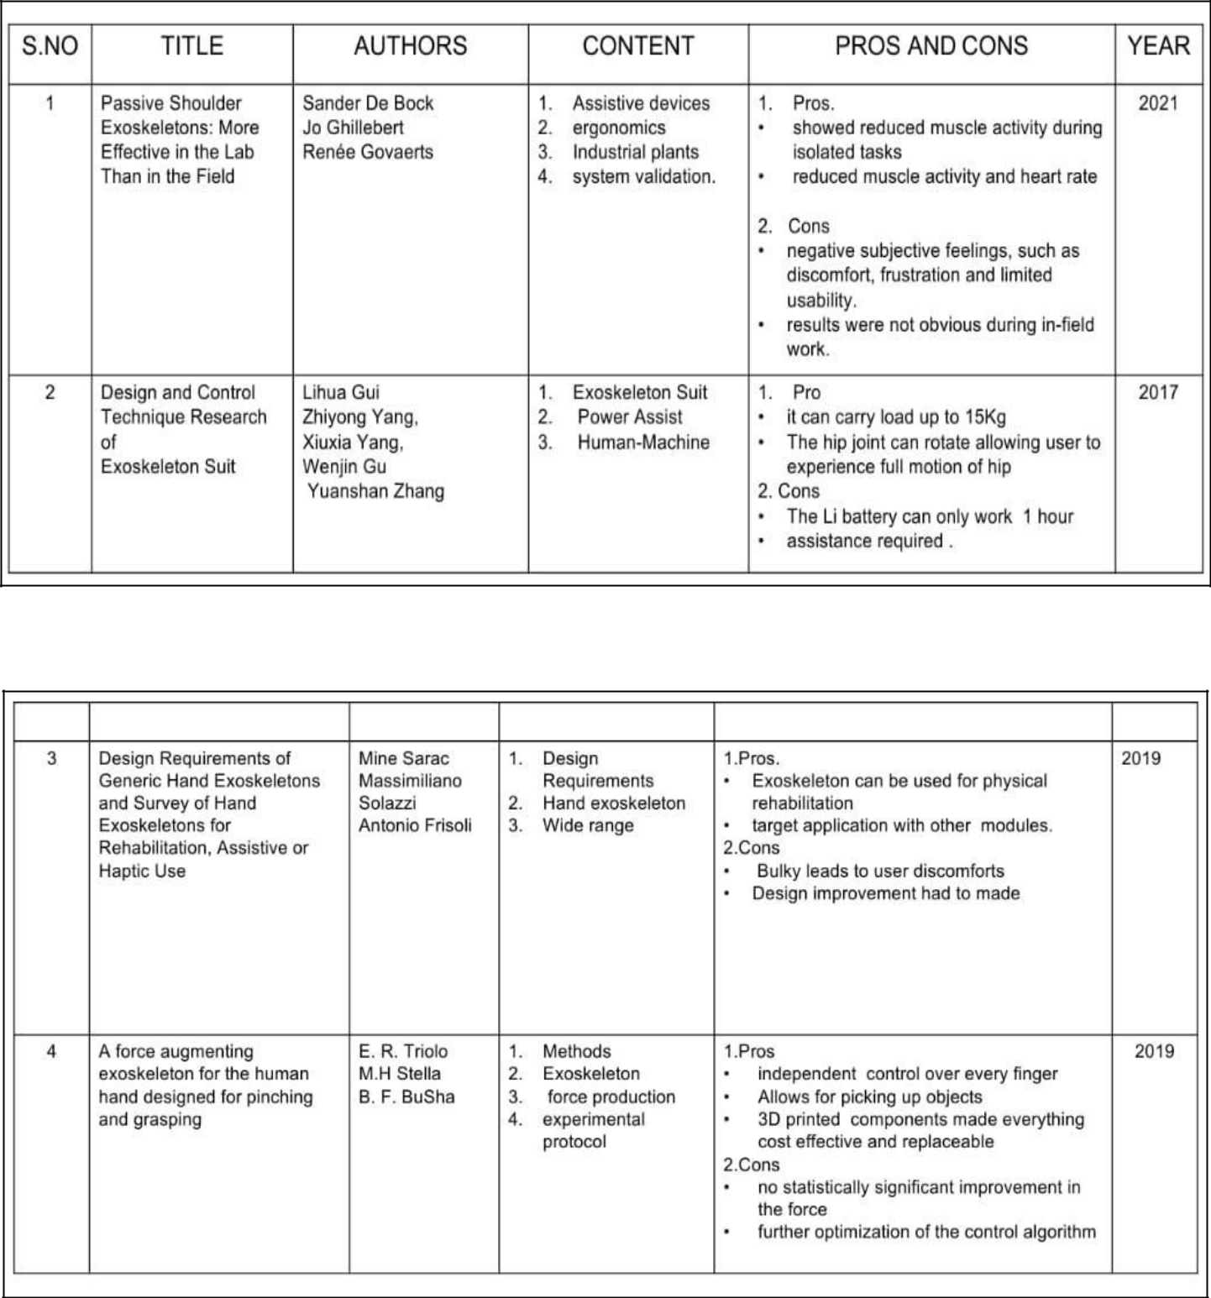

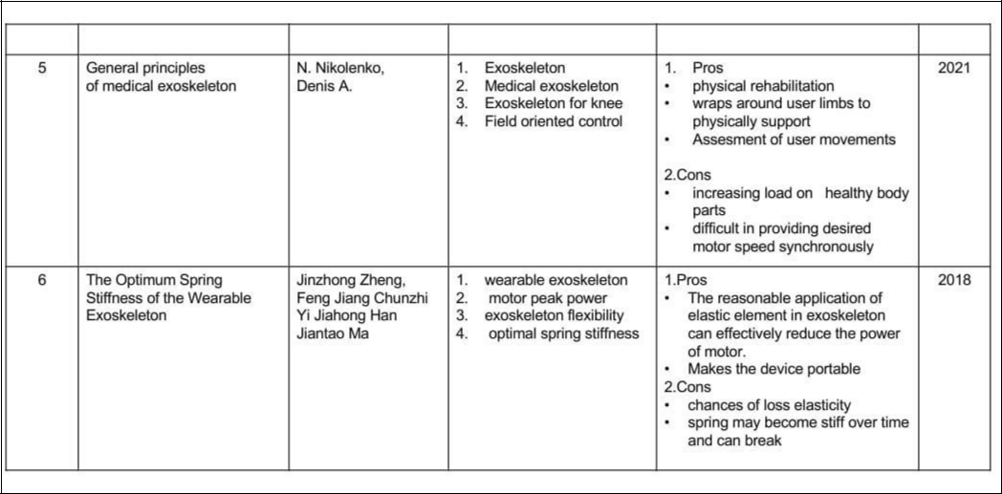

**CHAPTER 4**

**EXISTING SYSTEM**

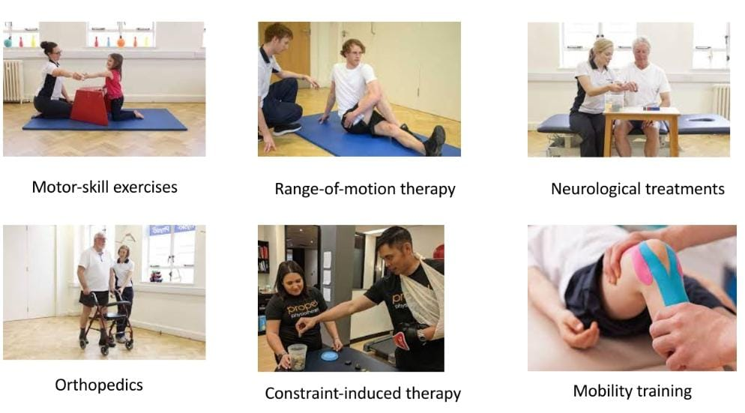Ischemic strokes are the most common type of stroke. They happen when a blood clot blocks the flow of blood and oxygen to the brain. These blood clots typically form in areas where the arteries have been narrowed or blocked over time by fatty deposits (plaques). Combination of medicines to treat the condition and prevent it happening again is usually recommended. As Medicine is a wide range of technology, we have several existing systems that includes as follows

Figure 4.1 Existing system

**4.1 Motor skills exercise**

Stroke is one of the leading causes for disability worldwide. Motor function deficits due to stroke affect the patients’ mobility. Motor function impairment, even the simplest tasks become difficult and frustrating. Picking up small objects, and fastening buttons can also be lost in the period following a stroke event. Rehabilitation training is the most effective way to reduce motor impairments in stroke patients. Fine motor skills play a major role in our ability to perform everyday tasks in an efficient manner. They’re what allow us to accurately grab an item, type words on a keyboard, and tie our shoelaces. After a stroke, individuals may struggle with tasks that involve fine motor skills. Fortunately, these skills can be improved through repetitive practice.

Some of the motor activities for adults after stroke are:

* 1. Therapy ball exercises
  2. Therapy putty exercises
  3. Music Glove hand therapy
  4. Rubber band resistance
  5. Play the piano
  6. **Mobility Training**

Mobility training combines mobility exercises that increase the range of movements and motions your body can perform. These include flexibility, but also balance, pliability and strength. The full combination is the best way to avoid injury. Mobility difficulties affect everyone differently. Your physiotherapist will assess how well you move, sit, stand and walk. They will then work with you to set goals and develop a rehabilitation program to meet your needs. It’s important to get all four types of exercise: endurance, strength, balance, and flexibility. Promotes good posture (looking at you, desk-workers), Helps prevent knots and injuries, functional fitness performance. These are the benefits of mobility training Each one has different benefits. Doing one kind also can improve your ability to do the others, and variety helps reduce boredom and risk of injury.

Mobility exercise includes:

* 1. Wrist Curls
  2. Shoulder Openers
  3. 3.Sit to Stand
  4. 4.Lateral Trunk Bends
  5. 5.Forward Trunk Bends
  6. **Constraint Induced Therapy**

Constraint-induced movement therapy is a form of rehabilitation therapy that improves upper

extremity function in stroke and other central nervous system damage patients by increasing

the use of their affected upper limb. Constraint-induced movement therapy is effective because

it stimulates the brain and promotes neuroplasticity. Neuroplasticity is the central nervous

system’s ability to reorganize itself and make adaptive changes. Due to its high duration of

treatment, the therapy has been found to frequently be infeasible. Constraint induced movement

therapy or CIMT is centered on retraining the brain following damage to improve functional

use of the weaker arm and hand.

CIMT involves two main components:

* Restraint of the unaffected arm using a mitt, sling or cast to encourage use of the weaker

arm

* Repetitive practice of functional tasks with the weaker hand. Activities may include

**4.4 Range of motion therapy**

Range of movement exercises are of 3 types:

1. 1.Active range of motion (AROM): performed by the patient independently.
2. 2.Active assisted range of motion (AAROM): performed when the patient needs assistance with movement from an external force because of weakness, pain, or changes in muscle tone.
3. 3.Passive range of motion (PROM): usually performed when the patient is unable or not permitted to move the body segment, and the clinician, or family member, moves the body segment.

**CHAPTER 5**

**PROPOSED SYSTEM**

This Exoskeleton provides an at-home option for therapeutic hand exercises to improve a patient's dexterity and restore function using 3D printing. It can be an interesting option for the supply of aids if the structural and functional properties of the neuromuscular and skeletal system are too limited to be able to achieve mobilization. It has a servo motor that bend and straighten the fingers and elbow, providing the stretching and repetitive exercise needed to restore lost hand function. Low pressure and comfortable materials make this device safe and desirable for repeated use.The control framework essentially reshapes the anisotropic force manipulability into the endpoint force manipulability that is invariant with respect to the direction in the entire workspace of the arm.

This allows users of the exoskeleton to perform tasks effectively in the whole range of the workspace, even in areas that are normally unsuitable due to the low force manipulability of the human arm.The minimalist form factor of soft robotics allows users to go about their daily activities without discomfort or frustration while wearing the glove in its unpowered state, and then smoothly transition into the 3D printed gadget like gloves powered assistance when they begin their therapeutic routine. The control system is portable and lightweight and can be placed anywhere. Using IoT and an application in mobile phones, the people anywhere can use them and control the patient’s physiotherapy without the help of attendees. These robotic gloves using 3D printing operate on the tendon’s principle. By temporarily moving the muscles to the hand, this design mimics the installation of the tendons in the human hand. The repetition of exercises is crucial to the recovery process.

**5.1 BLOCK DIAGRAM**

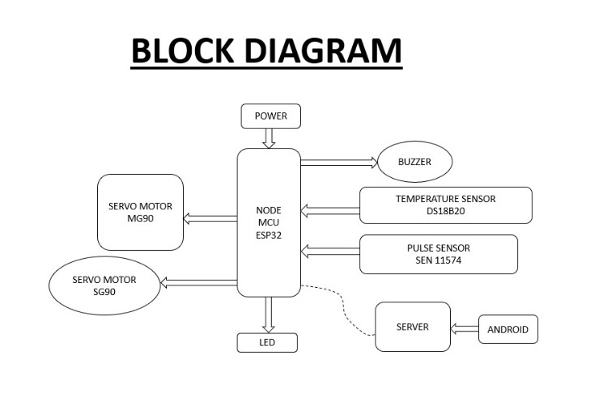

Figure 5.1 Block Diagram

**5.2 WORKING**

The system is designed as a robotic exoskeleton used for physiotherapy to help patients recover from accidents or the effects of a stroke. It consists of several modules that work together to achieve the goal. The main aspect of the system is simultaneous movement, which is essential for patient treatment.

To achieve this:

- An Android application, designed in Java, sends commands to a server. The person operating the application provides instructions based on the patient's needs.

- The server enables the generation of a dynamic and customized response to the client request. It uses the Python language in PyCharm.

- Later, NodeMCU receives the command from the server through serial communication. It utilizes embedded C with Arduino software (IDE).

The exoskeleton for the hand is made up of mainly 7 components that require continuous movement. These components include 5 fingers, the wrist, and the elbow. For rotary movement of the fingers and wrist, we utilize servo motors that typically come with a gear arrangement. This allows us to obtain high torque servo motors in small and lightweight packages. Servo motors are rated in kg/cm (kilograms per centimeter). Most hobby servo motors are rated at3kg/cm, 6kg/cm, or 12kg/cm. This rating indicates how much weight a servo motor can lift at a specific distance. However, in this case, since the fingers have less weight compared to the wrist, we need to make appropriate arrangements (fingers have up to 500gm/cm, and the wrist has up to 1 kg). As for the elbow, since it carries more weight, we are using a stepper motor driven by a motor driver module. This setup allows for precise control of the speed and direction. The motor driver module receives control signals from the controller and translates them into specific signals that govern the speed and direction of the DC motors. Additionally, the motor driver module provides sufficient power for the operation.

**5.3 CIRCUIT DIAGRAM**

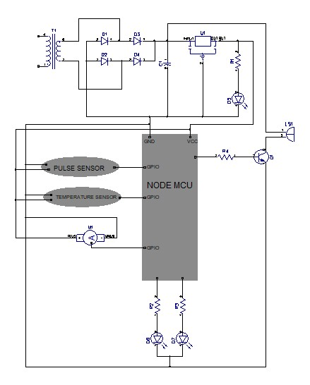

Figure 5.2 Circuit Diagram

The central block of the circuit diagram is the heart of the system: NodeMCU, which is a microcontroller. All peripheral devices are connected to its I/O pins. The power supply section consists of a step-down transformer used to reduce the voltage of the AC power source to a more manageable level. After the voltage is stepped down, a bridge rectifier is used to convert the AC voltage to a DC voltage. The bridge rectifier consists of four diodes arranged in a bridge configuration. When the AC voltage is applied across the input terminals of the bridge rectifier, the diodes conduct in a particular sequence depending on the polarity of the input voltage. This results in a pulsating DC voltage at the output of the bridge rectifier. A filter circuit is usually added to the output of the bridge rectifier to remove ripples.

The filter circuit consists of a capacitor and a resistor. The capacitor is charged during the periods when the diodes are conducting and discharges during the periods when the diodes are not conducting. The resistor helps to smooth out the output voltage by providing a path for the capacitor to discharge through.12V DC from the filter is given to a voltage regulator, which is a 3-pin IC, and it produces a 5V output. This 5V output is indicated by an LED protected by resistors. A stepper motor is used to control the elbow, and there are 6 servo motors used for controlling the fingers and wrist. These motors require 5V to operate and are connected to a NodeMcu..The LEDs connected below the NodeMcu in the diagram are used to check the working of the program and to indicate the boot status in response to requests from Android applications. The stepper motor is driven by a motor driver IC to control the elbow. The task is considered completed when the buzzer produces an output through a transistor. When a signal/trigger from the NodeMcu reaches the base of the transistor, current flows between the emitter and collector, causing the buzzer to produce sound. In this setup, the transistor acts as a switch.

**CHAPTER 6**

**HARDWARE**

**6.1 NODE MCU**

NodeMCU is an open-source firmware for which open-source prototyping board designs are available. The name “NodeMCU” combines “node” and “MCU” (micro-controller unit). The term “NodeMCU” strictly speaking refers to the firmware rather than the associated development kits. Both the firmware and prototyping board designs are open source. Nodemcu ESP8266 and Nodemcu ESP32 are becoming very popular and are almost used in more than 50% IoT based projects today. In addition, by providing some of the most important features of microcontrollers such as GPIO, PWM, ADC.

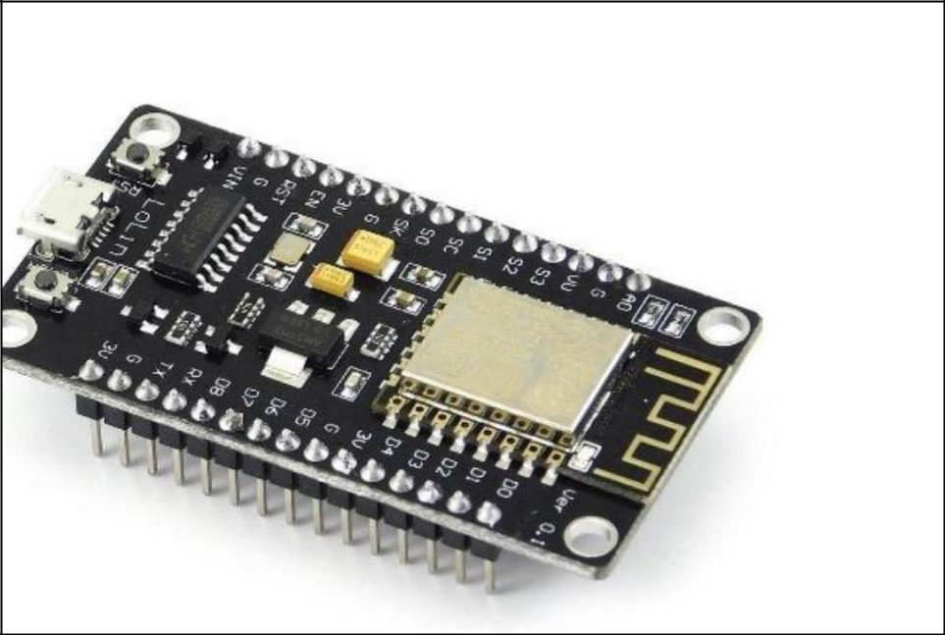

Figure 6.1 Node MCU

**6.2 SERVO MOTOR**

A servo motor is a type of motor that can rotate with great precision. Normally this type of motor consists of a control circuit that provides feedback on the current position of the motor shaft, this feedback allows the servo motors to rotate with great precision. If you want to rotate an object at some specific angles or distance, then you use a servo motor. It is just made up of a simple motor which runs through a servo mechanism. If a motor is powered by a DC power supply, then it is called a DC servo motor, and if it is AC-powered motor then it is called an AC servo motor. It is about the DC servo motor working. Apart from these major classifications, there are many other types of servo motors based on the type of gear arrangement and operating characteristics.

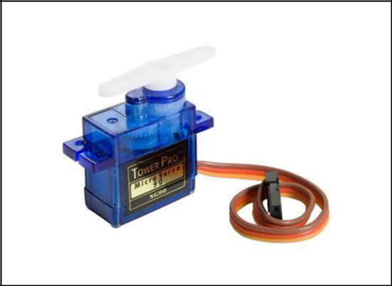

Figure 6.2 servo motor

A servo motor usually comes with a gear arrangement that allows us to get a very high torque servo motor in small and lightweight packages. Due to these features, they are being used in many applications like toy car, RC helicopters and planes, Robotics, etc.A servomotor is a linear actuator or rotary actuator that allows for precise control of linear or angular position, acceleration, and velocity. It consists of a motor coupled to a sensor for position feedback. It also requires a relatively sophisticated controller, often a dedicated module designed specifically for use with servomotors. There are some special types of applications of an electric motor where the rotation of the motor is required for just a certain angle. For these applications, we require some special types of motor with some special arrangement which makes the motor rotate a certain angle for a given electrical input.

**6.3 PULSE SENSOR**

A pulse wave is the change in the volume of a blood vessel that occurs when the heart pumps blood, and a detector that monitors this volume change is called a pulse sensor.

First, there are four main ways to measure heart rate: electrocardiogram, photoelectric pulse wave, blood pressure measurement, and phonocardiography. Pulse sensors use the photoelectric method. Pulse sensors using the photoelectric pulse wave method are classified into 2 types depending on the measurement method: transmission and reflection. Transmission types measure pulse waves by emitting red or infrared light from the body surface and detecting the change in blood flow during heart beats as a change in the amount of light transmitted through the body. This method is limited to areas where light can easily penetrate, such as the fingertip or earlobe. ROHM is currently developing a reflection-type pulse sensor (Optical Sensor for Heart Rate Monitor).The reflection-type pulse sensor (Optical Sensor for Heart Rate

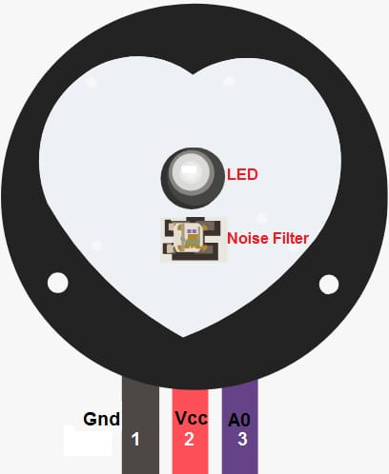

Figure 6.3 pulse sensor

**6.4 TEMPERATURE SENSOR**

The DS18B20 temperature sensor is a one-wire digital temperature sensor. This means that it just requires one data line (and GND) to communicate with the Arduino. It can be powered by an external power supply or it can derive power from the data line (called “parasite mode”), which eliminates the need for an external power supply. Each DS18B20 temperature sensor has a unique 64-bit serial code. This allows you to wire multiple sensors to the same data wire. So, you can get temperature from multiple sensors using just one Arduino digital pin.

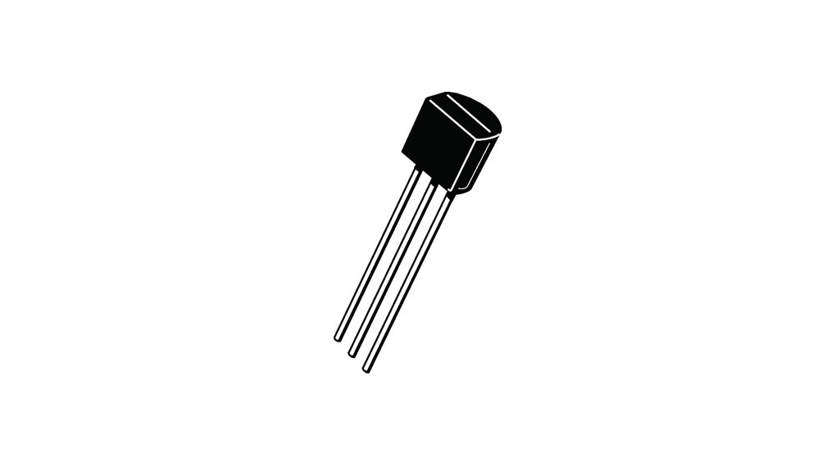

Figure 6.4 temperature sensor

**CHAPTER 7**

**SOFTWARE**

**7.1 ARDUINO IDE v1**

The Arduino IDE v1 works, such as compiling & uploading sketches, file management, installing dependencies and much more.The Arduino Integrated Development Environment - or Arduino Software (IDE) - contains a text editor for writing code, a message area, a text console, a toolbar with buttons for common functions and a series of menus. It connects to the Arduino hardware to upload programs and communicate with them.Programs written using Arduino Software (IDE) are called sketches. These sketches are written in the text editor and are saved with the file extension .ino. The editor has features for cutting/pasting and for searching/replacing text. The message area gives feedback while saving and exporting and also displays errors. The console displays text output by the Arduino Software (IDE), including complete error messages and other information. The bottom righthand corner of the window displays the configured board and serial port. The toolbar buttons allow you to verify and upload programs, create, open, and save sketches, and open the serial monitor.The Arduino Software (IDE) uses the concept of a sketchbook: a standard place to store your programs (or sketches). The sketches in your sketchbook can be opened from the File > Sketchbook menu or from the Open button on the toolbar. The first time you run the Arduino software, it will automatically create a directory for your sketchbook. You can view or change the location of the sketchbook location from with the Preferences dialog.The board selection has two effects: it sets the parameters (e.g. CPU speed and baud rate) used when compiling and uploading sketches; and sets and the file and fuse settings used by the burn bootloader command. Some of the board definitions differ only in the latter, so even if you've been uploading successfully with a particular selection you'll want to check it before burning the bootloader. Arduino Software (IDE) includes the built in support for the boards in the following list, all based on the AVR Core. The Boards Manager included in the standard installation allows to add support for the growing number of new boards based on different cores like Arduino Due, Arduino Zero, Edison, Galileo and so on. Support for third-party hardware can be added to the hardware directory of your sketchbook directory. Platforms installed there may include board definitions (which appear in the board menu), core libraries, bootloaders, and programmer definitions. To install, create the hardware directory, then unzip the third-party platform into its own sub-directory. (Don't use "arduino" as the sub-directory name or you'll override the built-in Arduino platform.) To uninstall, simply delete its directory

**7.2 PYCHARM**

PyCharm is an integrated development environment (IDE) used for programming in Python. It provides code analysis, a graphical debugger, an integrated unit tester, integration with version control systems, and supports web development with Django. PyCharm is developed by the Czech company JetBrains.It is cross-platform, working on Microsoft Windows, macOS and Linux. PyCharm has a Professional Edition, released under a proprietary license and a Community Edition released under the Apache License. PyCharm Community Edition is less extensive than the Professional Edition.

1. Coding assistance and analysis, with code completion, syntax and error highlighting, linter integration, and quick fixes
2. .Project and code navigation: specialized project views, file structure views and quick jumping between files, classes, methods and usages
3. Python code refactoring: including rename, extract method, introduce variable, introduce constant, pull up, push down and others
4. Python code refactoring: including rename, extract method, introduce variable, introduce constant, pull up, push down and others
5. Integrated Python debugger
6. Integrated unit testing, with line-by-line coverage
7. Google App Engine Python development
8. Version control integration: unified user interface for  Mercurial, Git, Subversion, Perforce and CVS with change lists and merge
9. Scientific tools integration: integrates with Python Notebook, has an interactive Python console, and supports Anaconda as well as multiple scientific packages including Matplotlib and NumPy

**7.3 ANDROID STUDIO**

Android Studio is the official integrated development environment (IDE) for Google's Android operating system, built on JetBrains' IntelliJ IDEA software and designed specifically for Android development. It is available for download on Windows, macOS and Linux based operating systems. It is a replacement for the Eclipse Android Development Tools (E-ADT) as the primary IDE for native Android application development.Android Studio was announced on May 16, 2013, at the Google I/O conference. It was in early access preview stage starting from version 0.1 in May 2013, then entered beta stage starting from version 0.8 which was released in June 2014. The first stable build was released in December 2014, starting from version 1.0. At the end of 2015, Google dropped support for Eclipse ADT, making Android Studio the only officially supported IDE for Android development. Android Studio supports all the same programming languages of IntelliJ (and CLion) e.g. Java, C++, and more with extensions, such as Go; and Android Studio 3.0 or later supports Kotlin and "all Java 7 language features and a subset of Java 8 language features that vary by platform version." External projects backport some Java 9 features. While IntelliJ states that Android Studio supports all released Java versions, and Java 12, it's not clear to what level Android Studio supports Java versions up to Java 12 (the documentation mentions partial Java 8 support). At least some new language features up to Java 12 are usable in Android. Once an app has been compiled with Android Studio, it can be published on the Google Play Store. The application has to be in line with the Google Play Store developer content policy.

**CHAPTER 10**

**FLOW CHART AND ALGORITHM**

**FLOW CHART**

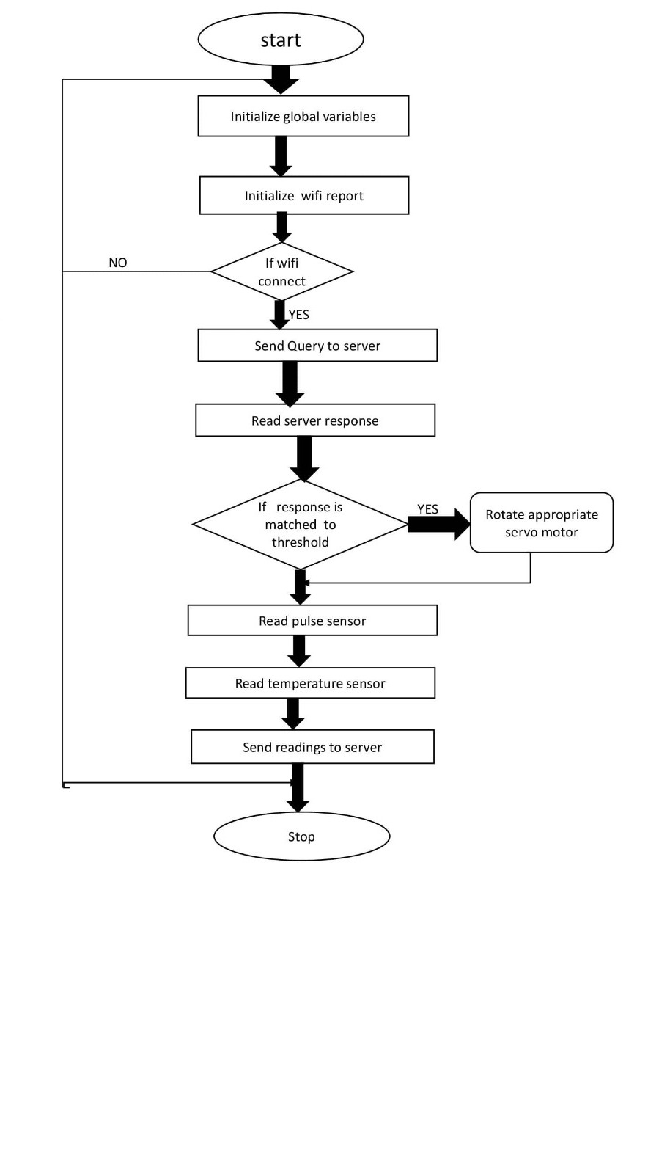

Figure 10.1 Flow chart

**ALGORITHM**

Step 1: Initialize global variable

Step 2: Initialize WiFi report

Step 3: If WiFi get's connected read server response .

If WiFi doesn't gets connected go to step 1

Step 4: If response is matched to threshold, rotate appropriate servo motors.

Step 5: Read pulse sensor

Step 6: Read temperature sensor

Step 7: Send these readings to server.

Step 9: produce output

**CHAPTER 11**

**ADVANTAGES AND DISADVANTAGES**

**ADVANTAGES**

* It is an easier and more effective therapy that is more precise with increased mobility and airflow materials.
* The most important thing is that everyone, even from lower economic backgrounds, can use it as it is cost-effective for patients.
* It is a low-complexity wearable exoskeleton system.
* It provides a more comfortable rehabilitation stage for post-treatment where patients can be in their comfort zone.
* It improves the economic background, technological background, and medical advancements in our country.
* Distance is not a matter between the person who is controlling the application and the patient.
* It is done automatically whenever they need treatment, and it can be done by any person (physiotherapist/physician/medical attendant/relatives/acquaintance/sometimes even the patient).
* Helps to find heart beat and body temperature using sensors

**DISADVANTAGES**

* It is important to note that the current technique is designed for people who are paralyzed on only one side. It assists the healthy side in simulating its movement for the paralyzed. Therefore, a fully paralyzed individual cannot use such a system.
* It needs maintenance and high care.
* Since it operates on Android applications, internet is required.

**CHAPTER 12**

**FUTURE SCOPE**

Exoskeletons have a versatile field of applications, such as the healthcare industry, to support limb amputees, paraplegic patients, or physically disabled individuals. They are also used in the defense industry to amplify power and in the manufacturing and construction industry to reduce worker muscle activity and fatigue. There are significant investments in healthcare projects, and Robotics and AI are revolutionizing the biomedical and health industries. Physiotherapists can benefit from using exoskeletons, as they increase the effectiveness of assessments and treatments and have the potential to completely change the way physiotherapy is delivered to patients in the future. Currently, medical exoskeleton technology is mainly used for rehabilitation and as a mobility aid. Rehabilitation robotics facilitate and support the movement of body parts, and they are also helpful in rehabilitation, training, and therapy. Robotic exoskeletons are an emerging technology being developed to augment human strength, with some designed for use in manual labor jobs to enhance workers' ability to lift heavy objects.

As our country has limited resources and a high population, the availability of medical facilities is often inadequate. In situations where there is a shortage of physiotherapists, physicians, medical attendants, or nurses, anyone can help the patients by using an Android application with control mechanisms. Even at home, if someone is occupied with other tasks, they can operate the exoskeletons remotely, regardless of the distance from the patient. This not only addresses the increasing difficulty of affording a physiotherapist but also improves the medical conditions of people from economically disadvantaged backgrounds and advances the technological capabilities of our country.

**CHAPTER 13**

**CONCLUSION**

A five-fingered, battery-powered, 3D-printed force-augmentation orthotic exoskeleton for the human hand was created in this study. With the five-digit exoskeleton, individuals may continue to independently operate each finger. Subjects were able to maintain autonomous finger mobility, pick up typical objects like a water bottle, as well as smaller, more delicate objects like a smartphone, while wearing the exoskeleton. This device can be extended and used anywhere on our body by changing the design of 3D printing accordingly. Compared to gloves made of cloth that feel sweaty and clumsy for patients, this device provides comfortable treatment without the need for excessive travel. Hence, the device's parts could be independently 3D-printed at a minimal cost, allowing for quick repair of damaged sections. This device can be managed with a mobile phone from anywhere, thanks to IoT. As a result of its modest weight, it is convenient and comfortable to use. The use of the device would allow the practice of object manipulation tasks even in subjects with poor hand extension ability and may be more effective than unassisted task practice for therapeutic gains. Future work will consist of extended independent home training with the device.The biggest advantage is that anyone can operate it from anywhere with the help of a pre-installed Android application that contains all control mechanisms, irrespective of the distance between the patient and the person who is controlling the application. Hence, everyone, even from a low economic background, can have access to these medical technologies and can also avoid the physiotherapists who are difficult to afford.

**REFERENCES**

[[1] IEEE TRANSACTIONS ON NEURAL SYSTEMS AND REHABILITATION ENGINEERING, VOL. 29, 2021 Clinical Test of a Wearable, High DOF, Spring Powered Hand Exoskeleton(HandSOME II)

[2] B. Siciliano and O. Khatib, Springer Handbook of Robotics, 2nd ed., Springer

International Publishing 2016.

[3] F. Cheraghpour, S. Moosavian and A. Nahvi, "Multiaspect grasp index for robotic arms," Scientia Iranica, vol. 18, no. 2, pp. 222-230, 2014.

[4] T. Rahman, W. Sample, S. Jayakumar, M. M. King and e. al., "Passive exoskeletons for assisting limb movement," Journal of Rehabilitation Research and Development, vol. 43, no. 5, pp. 583-590, 2010.

[5] G. Kwakkel and B. Kollen, “Predicting improvement in the upper paretic limb after stroke: A longitudinal prospective study,” Restorative Neurol. Neurosci., vol.m25, nos. 5–6, pp. 453–460, 2010

[6] D. G. Kamper and W. Z. Rymer, “Impairment of voluntary control of finger motion following stroke: Role of inappropriate muscle coactivation,” Muscle Nerve, vol. 24, no. 5, pp. 673–681, May 2009

[7] D. G. Kamper, H. C. Fischer, E. G. Cruz, and W. Z. Rymer, “Weakness is the primary contributor to finger impairment in chronic stroke,” Arch. Phys. Med. Rehabil., vol. 87, no. 9, pp. 1262–1269, 2006.

[8] V. S. Huang and J. W. Krakauer, “Robotic neurorehabilitation: A computational motor learning perspective,” J. Neuroeng. Rehabil., vol. 6, no. 1, p. 5, Dec. 2009.

[9] J. Mehrholz, M. Pohl, T. Platz, J. Kugler, and B. Elsner, “Electromechanical and robot assisted arm training for improving activities of daily living, arm function, and arm muscle strength after stroke,” Cochrane Database Syst. Rev., vol. 9, no. 9, Sep. 2018, Art. no. CD006876[Online]. Available: https://pubmed.ncbi.nlm.nih.gov/30175845/

[10] P. S. Lum, S. Mulroy, R. L. Amdur, P. Requejo, B. I. Prilutsky, and A. W. Dromerick, “Gains in upper extremity function after stroke via recovery or compensation: Potential differential effects on amount ofreal-world limb use, ” Topics Stroke Rehabil., vol. 16, no. 4, pp. 237–253, 2009.

**CERTIFICATES**



